1. **CORN HOLE**

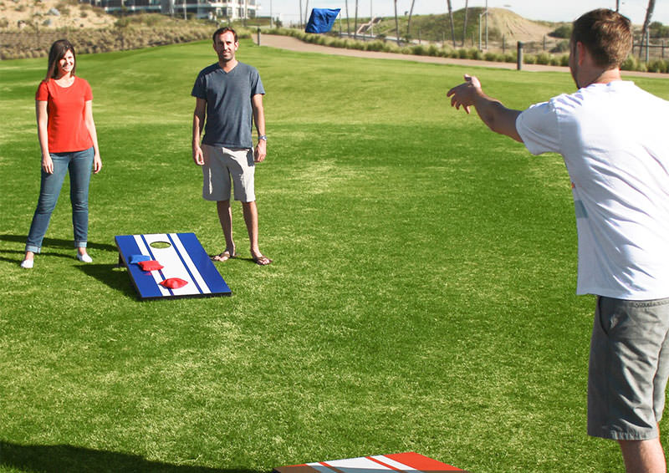

If you are throwing a summer party, cornhole is the game for you.

A little investment in this game can keep you occupied for a long time.

**You will need:**

Cornhole boards – 2

Cornhole bags – 4 for each team

**How to play:**

Place the boards on the ground.

Divide the players into two teams.

Stand some distance away from the boards and start throwing the bags on the board in turns.

Count the number of bags that landed correctly. The team with the maximum correct landings wins.

**2.CELEBRITY CHARADES**



It is a funnier version of the regular charades game and is best played

with celebrity-crazy friends.

**You will need:**

Slips of paper

A bowl

**How to play:**

Write the name of different celebrities (or the party guests) on the slips of paper, fold them, and drop them in the bowl.

Divide the players into two teams.

The players from each team take turns to pick a paper slip, read the name on it, and enact it to the other team members.

The team with the maximum right guesses wins

**3.MOVIE Id**



This game is best for hardcore movie buffs. You can even imitate your favorite movie stars if you can.

**You will need:**

A speaker

Audio clips from movies

**How to play:**

Play music or dialogue clips from movies.

The players have to guess the movie name from the id.

**4.DROP A HINT**



This is a team game that involves wordplay. If you and your friends know each other inside and out, play this game.

**You will need:**

Slips of paper

Timer

**How to play:**

Write different words or phrases on the slips of paper.

Divide the players into two teams.

A player from each team has to pick a slip, read the word/phrase written on it,

and drop one-word hints that will help the team’s other players guess the word within a minute.

**5.TRUTH OR DARE**

This is a team game

**You will need**:

Bottle

Players

**How to play:**

**1.**Choose friends

2.Make sure everyone is comfortable playing the game

3.Spends some time preparing truths and dares

4.Truth or dare game rules

5.Start the game

.

1. . Make sure everyone is sitting at one place in a circle or on a table.
2. Choose a participant either by spinning a bottle or picking the first one in the group.
3. The selected participant should say either truth or dare.
4. Anyone from the remaining group can give a truth or a dare depending on the participant choice.
5. Once the participant completes their truth or dares, repeat from Step 2.